

**LAB RECORD**

23CSE111 – Object Oriented Programming

***Submitted by***

CH.SC.U4CSE24103 – **B S CHENTHIL HARI**

**BACHELOR OF TECHNOLOGY**

IN

COMPUTER SCIENCE AND ENGINEERING

AMRITA VISHWA VIDYAPEETHAM

AMRITA SCHOOL OF COMPUTING

CHENNAI

November - 2024

## 

**AMRITA VISHWA VIDYAPEETHAM**

**AMRITA SCHOOL OF COMPUTING, CHENNAI**

**BONAFIDE CERTIFICATE**

This is to certify that the Lab Record work for 23CSE111- Computational Problem Solving Subject submitted by ***CH.SC.U4CSE24103 – B S CHENTHIL HARI*** in **“Computer Science and Engineering”** is a bonafide record of the work carried out under my guidance and supervision at Amrita School of Computing, Chennai.

This Lab examination held on 13/03/2025

|  |  |
| --- | --- |
| Internal Examiner 1 | Internal Examiner 2 |

# Index

|  |  |  |
| --- | --- | --- |
| **S.NO** | **Experiment Name** | **Page Number** |
| 1. | **Print Numbers from 1 to N** | 4 |
| 2. | Sum of First N Numbers | 5 |
| 3. | Check if a Number is Prime using for loop: | 6 |
| 4. | Fibonacci Series using while loop. | 7 |
| 5. | Reverse a String using for loop. | 8 |
| 6. | Find the Largest Number in an Array. | 9 |
| 7. | Count Vowels and consonants using string. | 10 |
| 8. | Check if a number is Armstrong or not. | 12 |
| 9. | Find GCD using while loop. | 13 |
| 10. | Check if a String is a palindrome. | 14 |
| 11. | Bank Management System UML | 15 |
| 12. | ATM Management System UML | 20 |

1.)

**Aim** : **Print Numbers from 1 to N**

**Program Code:**

**import java.util.Scanner;**

**public class PrintNumbers {**

**public static void main(String[] args) {**

**Scanner scanner = new Scanner(System.in);**

**System.out.print("Enter a number: ");**

**int n = scanner.nextInt();**

**for (int i = 1; i <= n; i++) {**

**System.out.println(i);**

**}**

**scanner.close();**

**}**

**}**

**Input:**

**Enter number:10**

**Output :**

1

2

3

4

5

6

7

8

9

10

2.)

**Aim :** Sum of First N Numbers

**Program Code:**

**import java.util.Scanner;**

**public class SumNumbers {**

**public static void main(String[] args) {**

**Scanner scanner = new Scanner(System.in);**

**System.out.print("Enter a number: ");**

**int n = scanner.nextInt();**

**int sum = 0;**

**for (int i = 1; i <= n; i++) {**

**sum += i;**

**}**

**System.out.println("Sum: " + sum);**

**scanner.close();**

**}**

**}**

**INPUT:**

Enter a number: 5

OUTPUT:

Sum: 15

3.)

Aim : Check if a Number is Prime using for loop:

Program Code:

import java.util.Scanner;

public class PrimeCheck {

public static void main(String[] args) {

Scanner scanner = new Scanner(System.in);

System.out.print("Enter a number: ");

int num = scanner.nextInt();

boolean isPrime = true;

if (num <= 1) {

isPrime = false;

} else {

for (int i = 2; i <= Math.sqrt(num); i++) {

if (num % i == 0) {

isPrime = false;

break;

}

}

}

if (isPrime)

System.out.println(num + " is a Prime number");

else

System.out.println(num + " is not a Prime number");

}

}

**Input:**

Enter a number : 17

**Output:**

17 is a Prime number.

4.)

**Aim :** Fibonacci Series using while loop.

**Program Code:**

import java.util.Scanner;

public class FibonacciWhile {

public static void main(String[] args) {

Scanner scanner = new Scanner(System.in);

System.out.print("Enter the number of terms: ");

int n = scanner.nextInt();

int a = 0, b = 1, i = 1;

while (i <= n) {

System.out.print(a + " ");

int temp = a + b;

a = b;

b = temp;

i++;

}

}

}

**Output:**

Enter the number of terms: 7

0 1 1 2 3 5 8

5.)

**Aim:** Reverse a String using for loop

**Program Code:**

import java.util.Scanner;

public class ReverseString {

public static void main(String[] args) {

Scanner scanner = new Scanner(System.in);

System.out.print("Enter a string: ");

String str = scanner.nextLine();

String reversed = "";

for (int i = str.length() - 1; i >= 0; i--) {

reversed += str.charAt(i);

}

System.out.println("Reversed String: " + reversed);

}

}

**Output:**

Enter a string: hello

Reversed String: olleh

6.)

**Aim :** Find the Largest Number in an Array.

**Program Code:**

public class LargestInArray {

public static void main(String[] args) {

int[] numbers = {10, 45, 78, 23, 56, 89, 12};

int max = numbers[0];

for (int num : numbers) {

if (num > max) {

max = num;

}

}

System.out.println("Largest number: " + max);

}

}

**Output:**

Largest number: 89

7.)

**Aim :** Count Vowels and consonants using string

**Program Code:**

import java.util.Scanner;

public class VowelConsonantCount {

public static void main(String[] args) {

Scanner scanner = new Scanner(System.in);

System.out.print("Enter a string: ");

String str = scanner.nextLine().toLowerCase();

int vowels = 0, consonants = 0;

for (char ch : str.toCharArray()) {

if (ch >= 'a' && ch <= 'z') {

if ("aeiou".indexOf(ch) != -1) {

vowels++;

} else {

consonants++;

}

}

}

System.out.println("Vowels: " + vowels);

System.out.println("Consonants: " + consonants);

}

}

**Output :**

Enter a string: Java Programming

Vowels: 5

Consonants: 9

8.)

**Aim :** Check if a number is Armstrong or not.

**Program Code :**

import java.util.Scanner;

public class ArmstrongNumber {

public static void main(String[] args) {

Scanner scanner = new Scanner(System.in);

System.out.print("Enter a number: ");

int num = scanner.nextInt();

int originalNum = num, sum = 0, digits = String.valueOf(num).length();

while (num > 0) {

int digit = num % 10;

sum += Math.pow(digit, digits);

num /= 10;

}

if (sum == originalNum)

System.out.println(originalNum + " is an Armstrong number");

else

System.out.println(originalNum + " is not an Armstrong number");

}

}

**Output :**

Enter a number: 153

153 is an Armstrong number

9.)

**Aim :** Find GCD using while loop.

**Program Code:**

import java.util.Scanner;

public class GCDExample {

public static void main(String[] args) {

Scanner scanner = new Scanner(System.in);

System.out.print("Enter two numbers: ");

int a = scanner.nextInt(), b = scanner.nextInt();

while (b != 0) {

int temp = b;

b = a % b;

a = temp;

}

System.out.println("GCD: " + a);

}

}

**Output :**

Enter two numbers: 48 18

GCD: 6

10.)

**Aim:** Check if a String is a palindrome.

**Program Code:**

import java.util.Scanner;

public class PalindromeCheck {

public static void main(String[] args) {

Scanner scanner = new Scanner(System.in);

System.out.print("Enter a string: ");

String str = scanner.nextLine();

String reversed = new StringBuilder(str).reverse().toString();

if (str.equals(reversed))

System.out.println(str + " is a Palindrome");

else

System.out.println(str + " is not a Palindrome");

}

}

**Output :**

Enter a string: madam

madam is a Palindrome

Banking System UML:

1. Class Diagram:

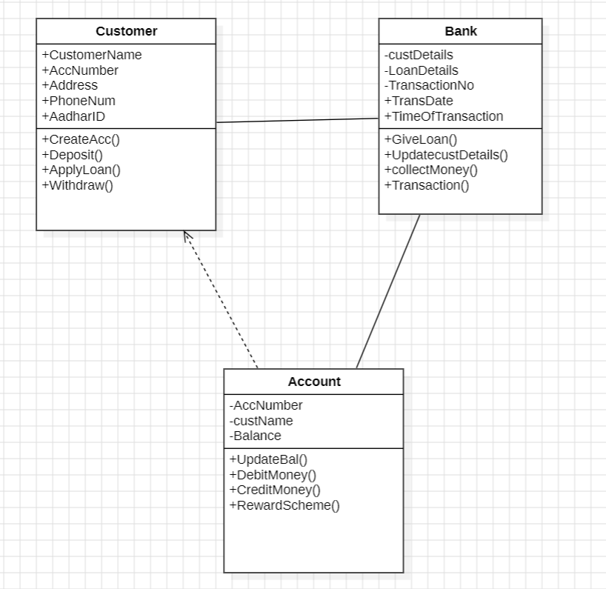

2. Use Case Diagram:

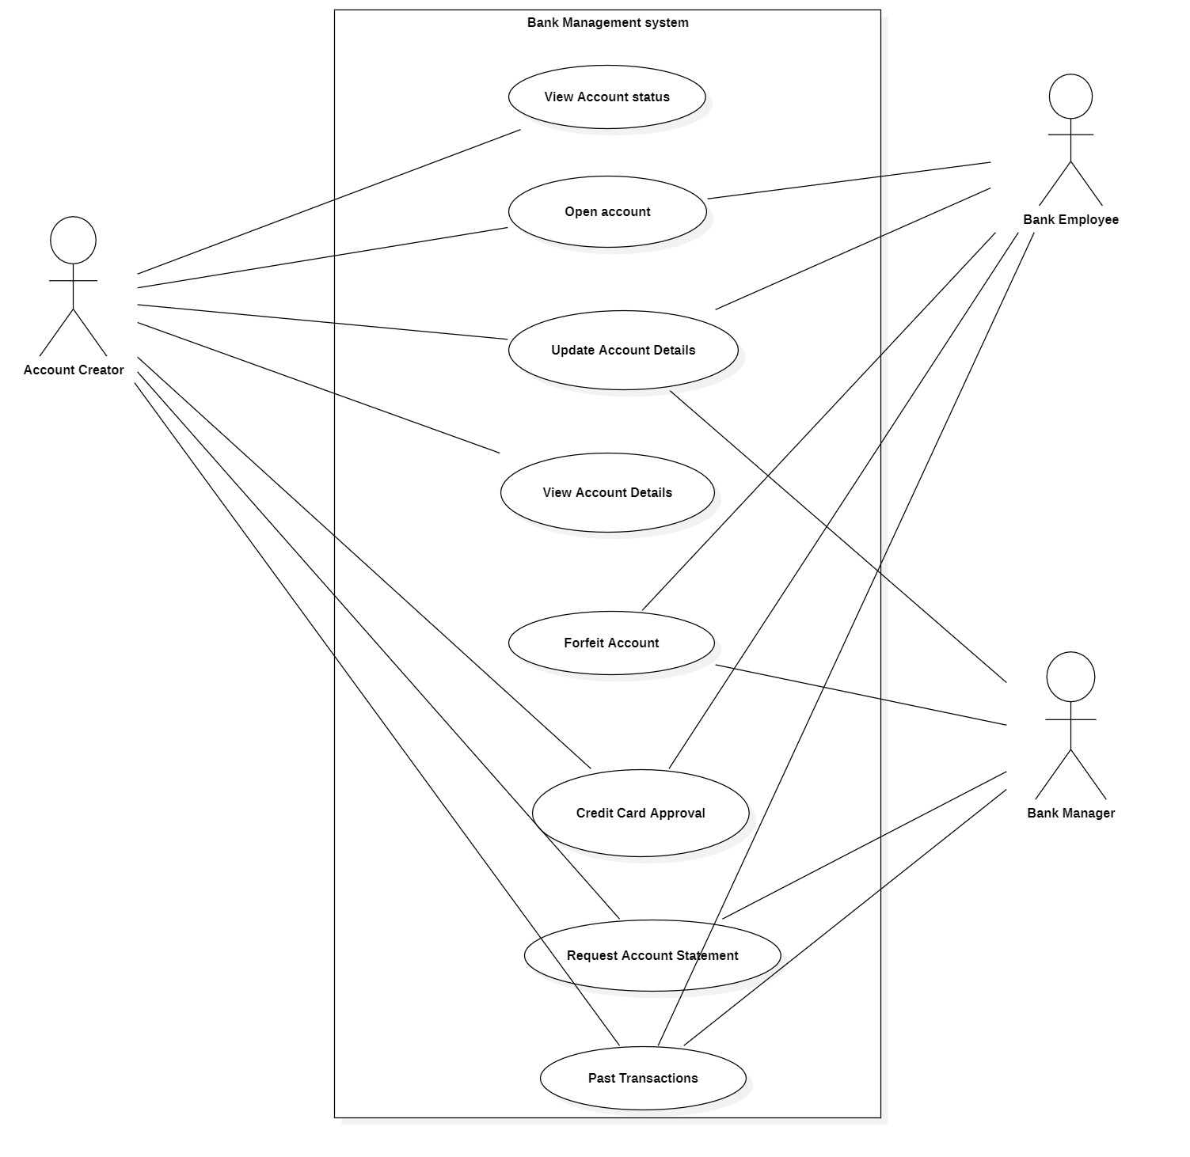

3. Sequence Diagram:  
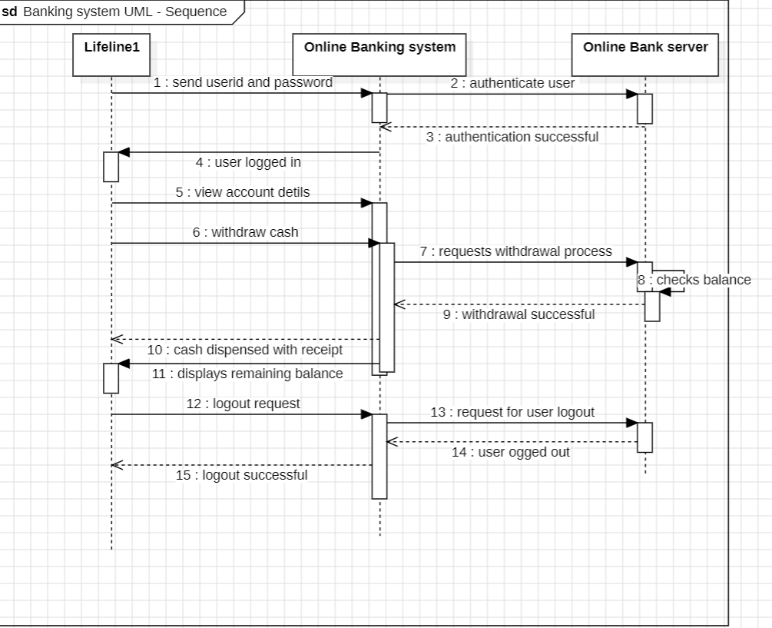

4. State Diagram:

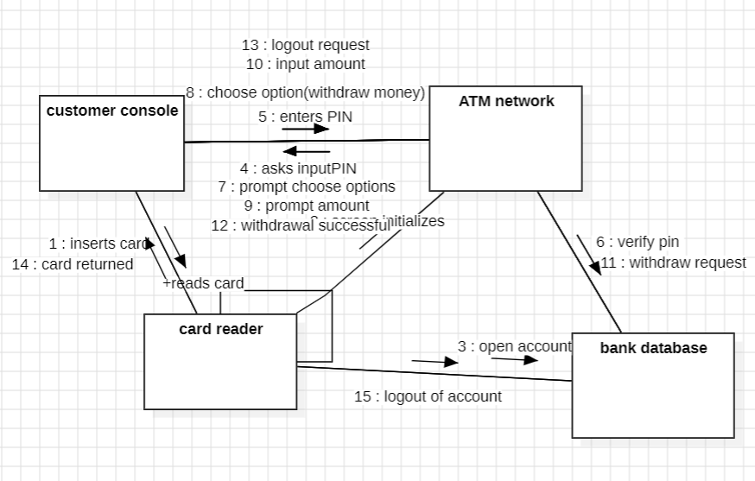

5.collabration:

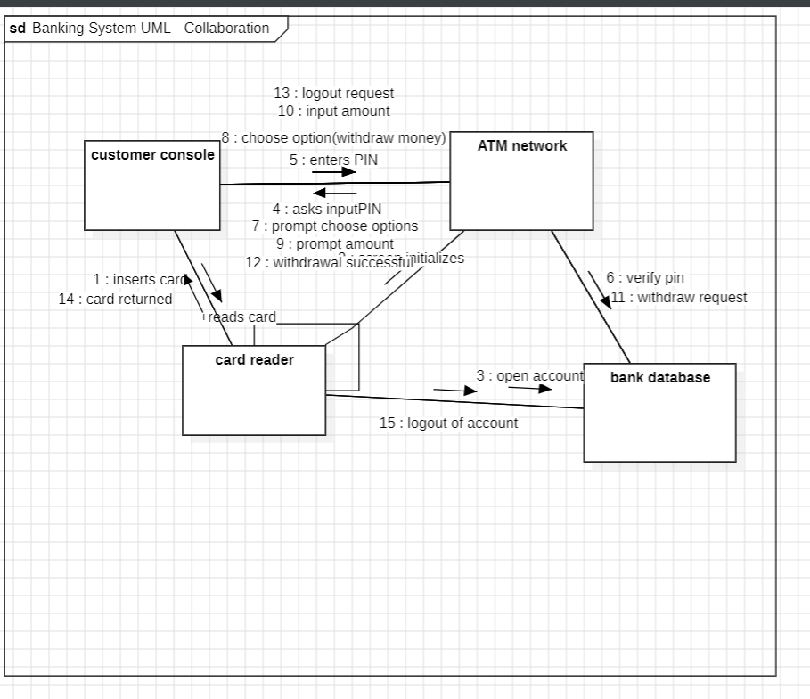

2.Book Purchase:

1)Class diagram:

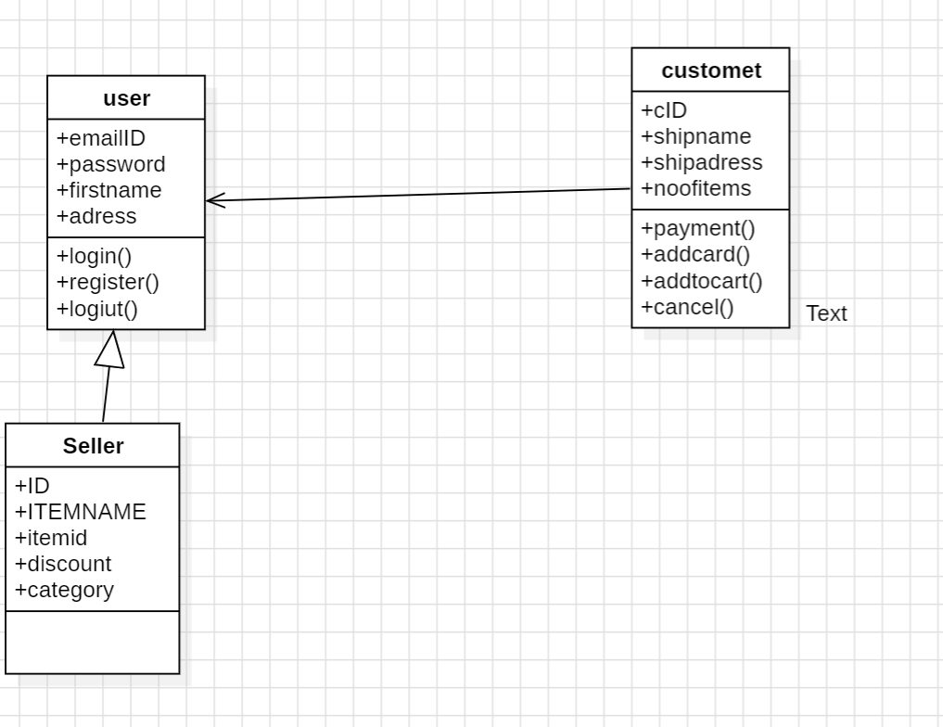

2)Activity:

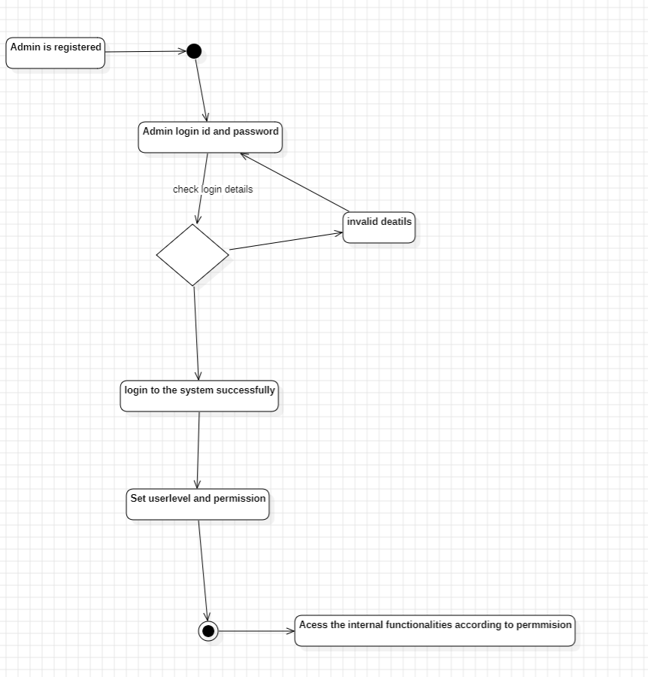

3)Sequence diagram:

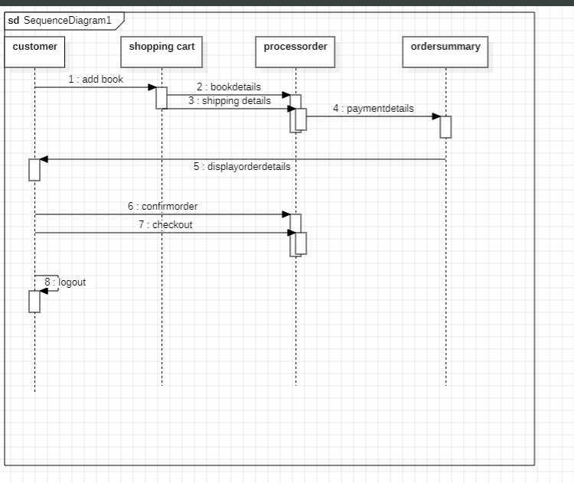

4)collabration diagram:

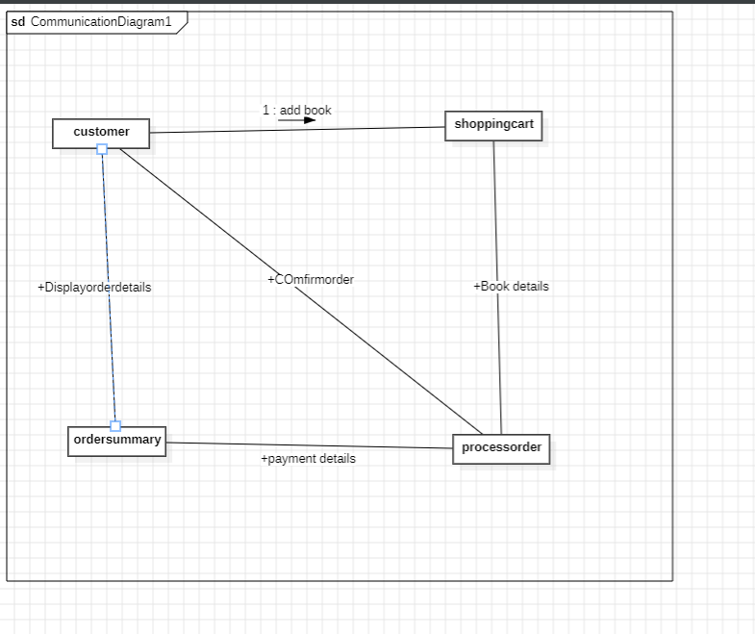

5)usecase:

